**Basic knowledge about HTML:-**

🡪HTML stands for hypertext markup language.

🡪It’s used to design websites

🡪It consist of two parts hypertext and markup language.

🡪Hypertext used to link websites and markup language is used to structure of a website.

🡪HTML1 (1993) and HTML5(2014)

**TAGS and Elements:-**

🡪HTML Tags are the predefined element which are used to add more features to content .

e.g <br>🡪 next line

<h1></h1> 🡪heading 1

🡪Its tage are not case sensitives.

🡪Most of the HTML tags have closed tag.

**HTML basic structure:-**

<!DOCTYPE html> 🡪It tells about its document type

<html lang="en"> 🡪root element all elements it contains

<head> 🡪It contains backend process of web page

    <title>Document</title>

</head>

<body>🡪 It contains all visible content of frontend of website

    hello this my first html page so don't judge ra!!!

</body>

</html>

**Features of HTML:-**

* It is easy to learn and easy to use.
* It is platform-independent.
* Images, videos, and audio can be added to a web page.

**Tags:-**

* Head tag:- It is used to define the heading of an HTML document. E.g <h1><h2><h3><h4><h5>< h6> all have closing tags
* Paragraph tag**:-** It is used to define paragraph content in an HTML document. E.g <p></p>
* Bold tag: It is used to specify bold content in an HTML document. e.g <b></b>
* Italic tag: It is used to write the content in italic format. E.g <i></i>
* Underline tag: It is used to set the content underline. E.g <u></u>
* Deleted text tag: It is used to represent deleted text. It crosses the text content.

e.g. <strike>Trese</strike>Trees

<br> = breakline, <hr>=head ruler

* Anchor tag: It is used to link one page to another page.

e.g. <a href=”link of other page here”>Give title to link </a>

🡪<pre> </pre> tag is special type of tag which is used to omit the basic function of html that it treat elements hold togather even all the elements belongs to other tag. We can also use <br> **break** function but its easy to assign pre at start of body and end before the closing of body.

**HTML elements:**

* An HTML element is defined by a start tag, some content, and an end tag.
* The HTML element is everything from the start tag to the end tag.
* HTML elements can be nested (this means that elements can contain other elements).

**HTML attributes:**

* HTML attributes provide additional information about HTML elements.
* All HTML elements can have attributes
* Attributes are always specified in the start tag

**HTML formatting:**

Formatting elements were designed to display special types of text:

* <b>  </b>- Bold text
* <strong> </strong> - Important text
* <i>  </i>- Italic text
* <em> </em> - Emphasized text (typically displayed in Italic)
* <mark>  </mark>- Marked text (marked or highlighted)
* <small> </small> - Smaller text (smaller text size)
* <del> </del>- Deleted text (crossed line over text)
* <ins> </ins>- Inserted text (text inserted into document)
* <sub> </sub>- Subscript text
* <sup> </sup>- Superscript text

**CODE:-**

<!DOCTYPE html>

<html lang="en">

<head>

    <meta charset="UTF-8">

    <meta name="viewport" content="width=device-width, initial-scale=1.0">

    <title>Document</title>

</head>

<body>

   <pre>

    <h1>ADITYA DAS</h1>

    <h2>ADITYA DAS</h2>

    <h3>ADITYA DAS</h3>

    <h4>ADITYA DAS</h4>

    <h5>ADITYA DAS</h5>

    <h6>ADITYA DAS</h6>

    <p> hello this my first html page so don't judge ra!!! </p>

    <b>hello</b>

    <i>hello</i>

    <u>hello</u>

    <del>hello </del> hii

    <strike>adityaaaa</strike>ADITYA

    <a href="1.html">same page link</a>

    <e>hello</e>

    <strong>aditya das</strong>

    <mark>aditya das</mark>

    <small>aditya </small>

    <big>aditya </big>

    <ins>hello</ins>

    <p>H<sub>2</sub>O</p>

    <p>2<sup>3</sup>=8</p>

</pre>

</body></html>

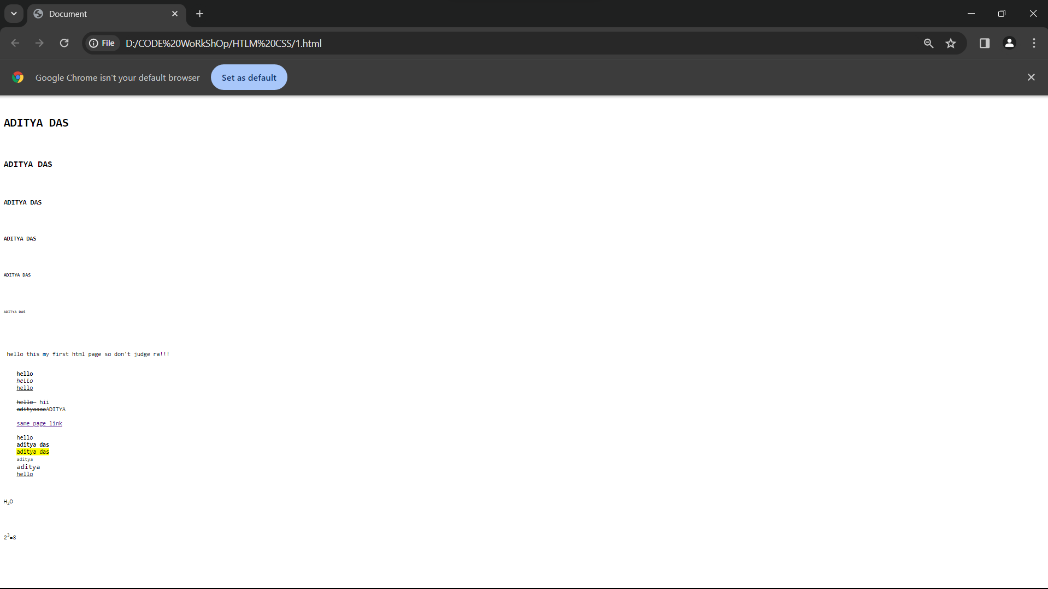

* For creating comment in HTML use this symbol <!--comment -->

**Grouping content:**

* Grouping plays a vital role in our web page because it helps the developer to target specific classes and id which makes it easier to position, style, or manipulate the web page with the help of HTML.
* <div>: It is a block-level tag that groups various HTML tags into a single block.
* <header> **:**This tag contains the tagline or we can say it contains the main heading or the navigation links of our web page and is placed at the top of our web page. (written inside the body tag)
* <section>: This tag is used to define the section in the document.
* <footer>: This tag contains copyright information, contact information, back-to-top link, and several other related documents and is placed at the bottom of our web page.

**HTML fonts:**

* **Font tag:** It is used to specify the font size, font color, and font family in an HTML document.

**<p><font face="Times New Roman">text </font></p>**

* Background color:

**<p style="background-color: yellow;">hello</p>**

* **Text color:**

**<p style="color: blue;">hello</p>**

* **Border color:**

**<p style="border:30px solid yellow;">fhello</p><p style="border:30px solid yellow;">fhello</p>**

**CODE:-**

<html>

<head>

    <meta charset="UTF-8">

    <meta name="viewport" content="width=device-width, initial-scale=1.0">

    <title>Document</title>

</head>

<body>

    <p><font face="Times New Roman">text </font></p>

    <p style="background-color: yellow;">hello</p>

    <p style="color: blue;">hello</p>

    <p style="border:30px solid yellow;">fhello</p>

</body>

</html>

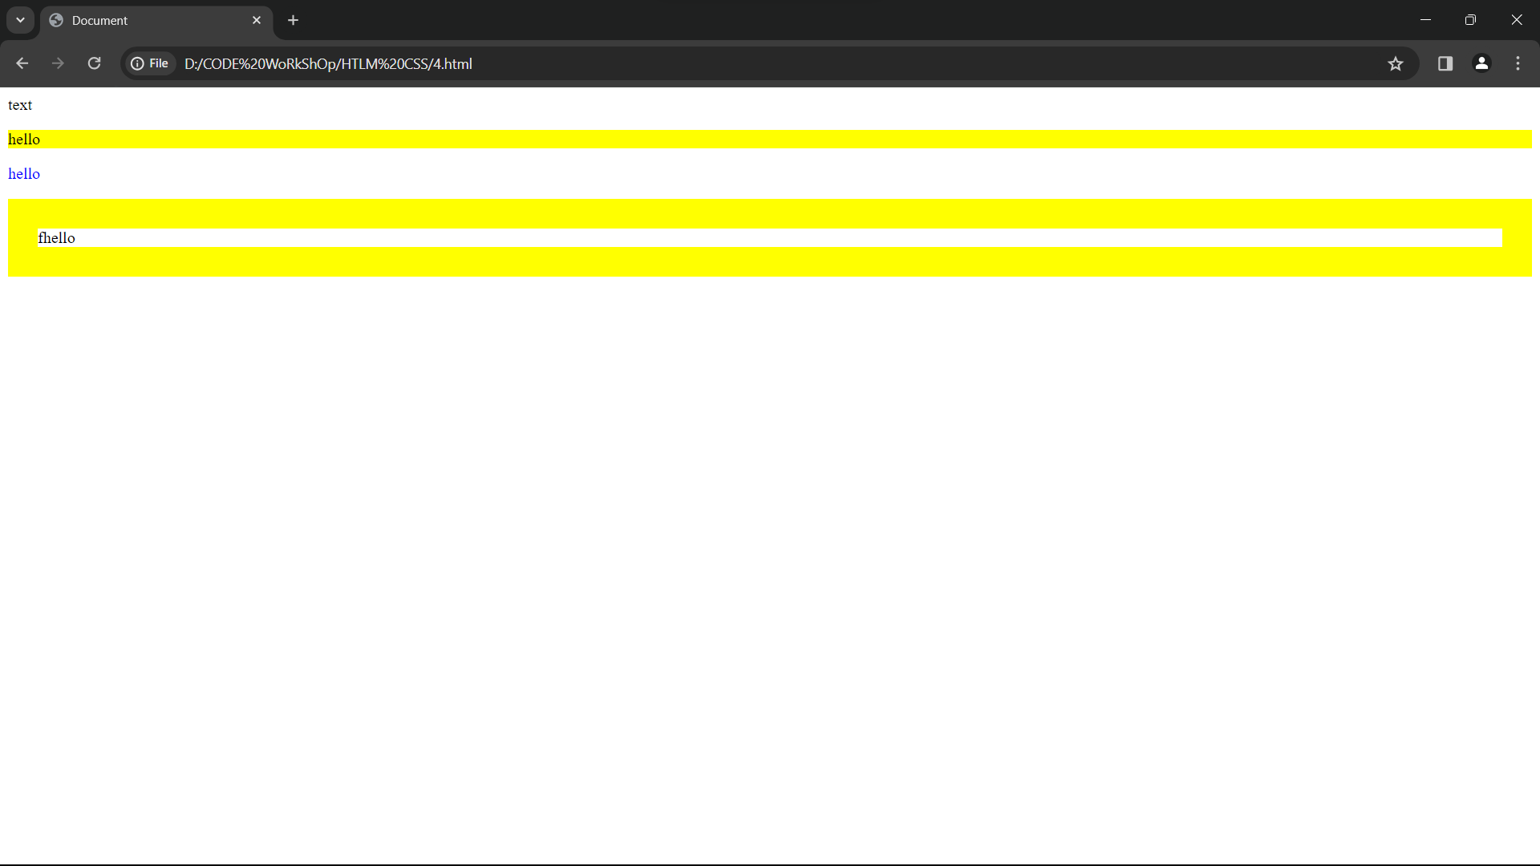

HTML image and video src:-

* <img src=”source path”>:- This tag is used to show image on website
* <vid src=”source path”>:- This tag is used to show video on website

🡪**alt** is an attribute used to show the text form of image if image is not seen

🡪**control** is an attribute to provide control to video by playing and pause it.

🡪**height** and **width** also attribute to adjust the height and width of video as well as image

CODE:-

<!DOCTYPE html>

<html lang="en">

<head>

    <meta charset="UTF-8">

    <meta name="viewport" content="width=device-width, initial-scale=1.0">

    <title>Document</title>

</head>

<body>

    <img src="C:\Users\ADITYA DAS\Pictures\01.jpg">

    <video src="E://CODE RELATED VIDEO//AI creation.mp4" alt="video" controls height="300px"></video>

</body>

</html>

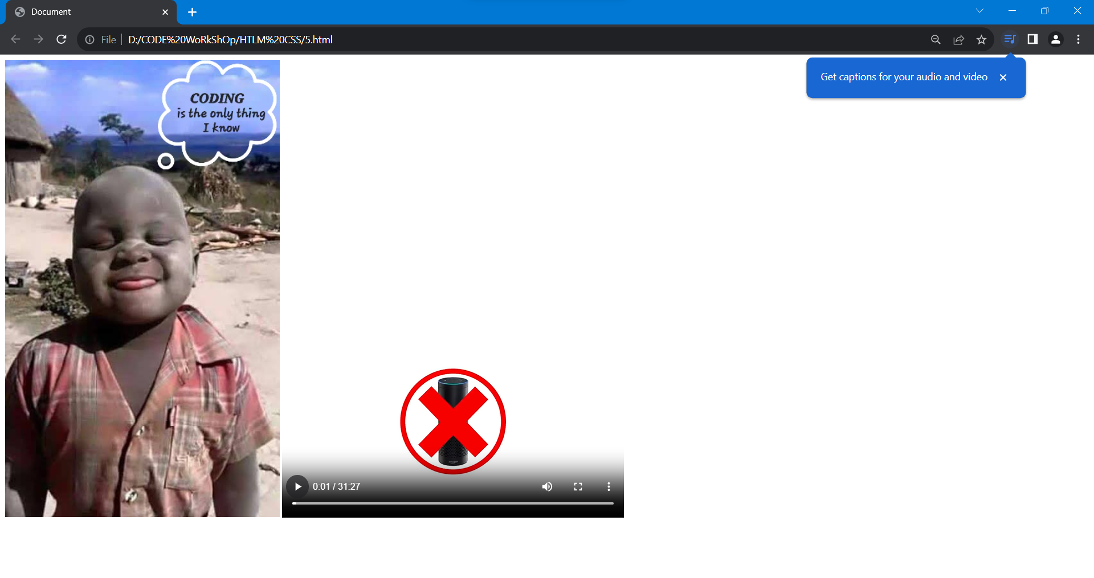

**HTML Lists:**

* **List tag:** It is used to list the content.

**🡪**Types of list in html are **unordered list (ul)** and **ordered list (ol)**

**🡪**adding **type** attribute in **ol** will give output as roman number,alphabatical order,Numrical number if we use as the following (**A,a,i,I,1**)

Code:-

<!DOCTYPE html>

<html lang="en">

<head>

    <meta charset="UTF-8">

    <meta name="viewport" content="width=device-width, initial-scale=1.0">

    <title>Document</title>

</head>

<body>

    <ul>

        <li>one</li>

        <li>two</li>

        <li>three</li>

    </ul>

    <ol type="1">

        <li>one</li>

        <li>two</li>

        <li>three</li>

    </ol>

</body>

</html>

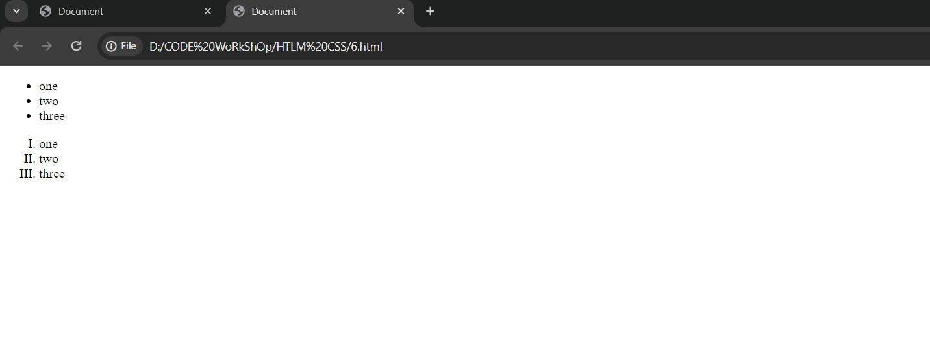

**HTML Table:**

* **Table tag: A table** tag is used to create a table in an HTML document.
* **td tag:** It defines the standard cell in a HTML document.
* **tr tag:** It is used to define a row of an HTML table.
* **th tag:** It defines the header cell in a table. By default, it set the content with the bold and center property.

🡪border attribute for table which provide border to table.

**CODE:-**

<!DOCTYPE html>

<html lang="en">

<head>

    <meta charset="UTF-8">

    <meta name="viewport" content="width=device-width, initial-scale=1.0">

    <title>Document</title>

</head>

<body>

    <table border="3px">

        <tr>

            <th>Name</th>

            <th>Roll </th>

        </tr>

        <tr>

            <td>Aditya das</td>

            <td>22CSE902</td>

        </tr>

        <tr>

            <td>Sagar</td>

            <td>22CSE</td>

        </tr>

    </table>

</body>

</html>

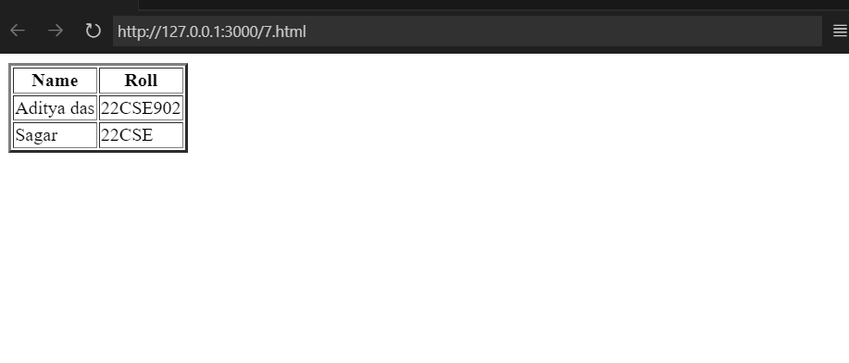

* Cell padding is the space between the cell edges and the cell content.
* Cell spacing is the space between each cell.

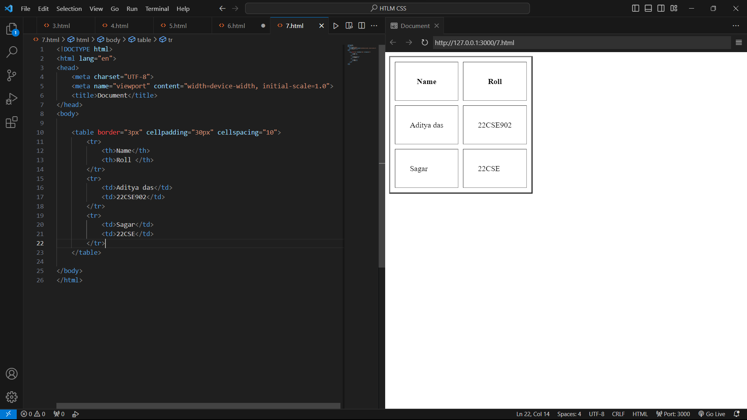

* **Column span**

🡪specifies the number of columns a cell should span.

🡪It allows the single table cell to span the width of more than one cell or column.

🡪It provides the same functionality as “merge cell” in a spreadsheet program like Excel.

🡪 It can be used with **<td>**and **<th>** element while creating an HTML Table.

* **Row span**

🡪The rowspan attribute in HTML specifies the number of rows a cell should span.

🡪That is if a row spans two rows, it means it will take up the space of two rows in that table.

🡪It allows the single table cell to span the height of more than one cell or row.

🡪It provides the same functionality as “merge cell” in the spreadsheet program like Excel.

CODE:-

<!DOCTYPE html>

<html lang="en">

<head>

    <meta charset="UTF-8">

    <meta name="viewport" content="width=device-width, initial-scale=1.0">

    <title>Document</title>

</head>

<body>

    <table border="3px">

        <caption>Student table</caption> <!--Table name mentioned with caption tag-->

        <tr>

            <th colspan="2">Name</th>

            <th>Roll Number</th>

            <th>Number</th>

            <th>Registration</th>

        </tr>

        <tr>

            <td>aditya das</td>

            <td>sagar</td>

            <td rowspan="2">22CSE902</td>

            <td>111</td>

            <td>11111</td>

        </tr>

        <tr>

            <td>aditya das</td>

            <td>sagar</td>

            <td>22CSE902</td>

            <td>111</td>

            <td>11111</td>

        </tr>

    </table>

</body>

</html>

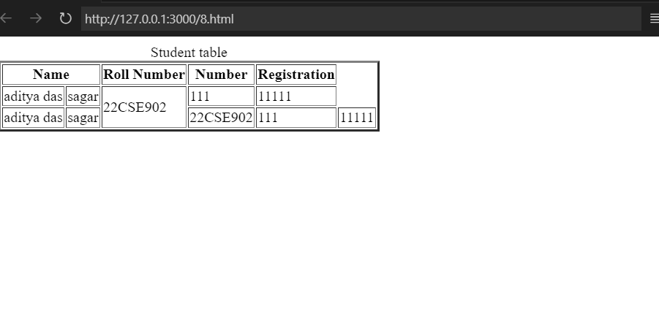

**HTML text links: (Anchor tag)**

* A webpage can contain various links that take you directly to other pages and even specific parts of a given page. These links are known as hyperlinks.
* Hyperlinks allow visitors to navigate between Web sites by clicking on words, phrases, and images. Thus you can create hyperlinks using text or images available on a webpage.
* target is attribute which used to tell hyperlink to open in same tab or open in another tab.It can be of different type:-

**🡪 _blank**

Opens the linked document in a new window or tab.

* **_self**

Opens the linked document in the same frame.

* **_parent**

Opens the linked document in the parent frame.

* **_top**

Opens the linked document in the full body of the window.

Note:-

Mainly we use _self and _blank

**CODE:-**

<!DOCTYPE html>

<html lang="en">

<head>

    <meta charset="UTF-8">

    <meta name="viewport" content="width=device-width, initial-scale=1.0">

    <title>Document</title>

</head>

<body>

    <pre>

    clickable link

    <a href="3.html" target="_blank">click here to go move up and down website</a>

    clickable image

    <a href="1.html" target="_self"><img src="C:\Users\ADITYA DAS\Pictures\01.jpg"></a>

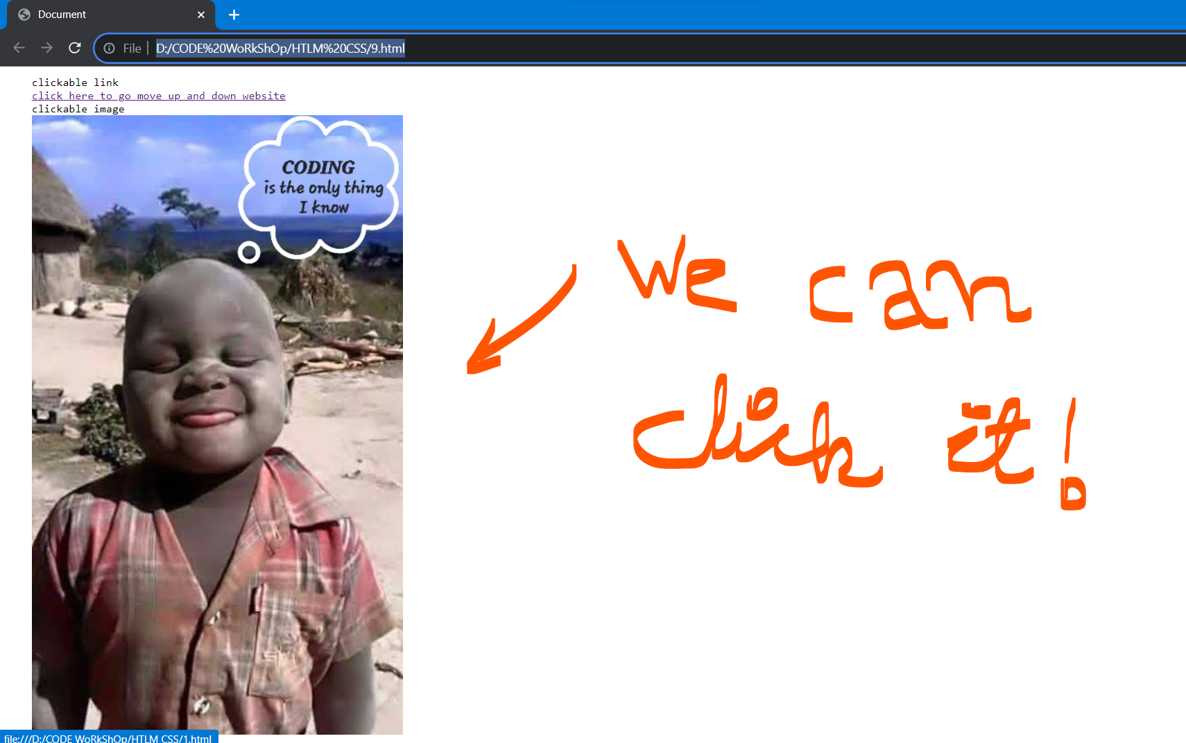

</pre>

</body>

</html>

Output🡪

**HTML frames: (Frameset)**

* Note:- Frameset are usually written in head tag.
* HTML <frameset> tag define the particular area within an HTML file where another HTML web page can be displayed.
* A <frame> tag is used with <frameset> , and it divides a webpage into multiple sections or frames, and each frame can contain different web pages.
* Two types of frames:
  + Vertical frames
  + Horizontal frames

***SYNTAX:-***

______ 🡪 cols or rows

🡪<Frameset _____ =”30%,40%,30%”>

<frame src=””>

<frame src=””>

<frame src=””>

</Frameset>

<!DOCTYPE html>

<html lang="en">

<head>

    <frameset rows="30%,40%">

        <frame src="2.html">

        <frame src="3.html">

    </frameset>

</head>

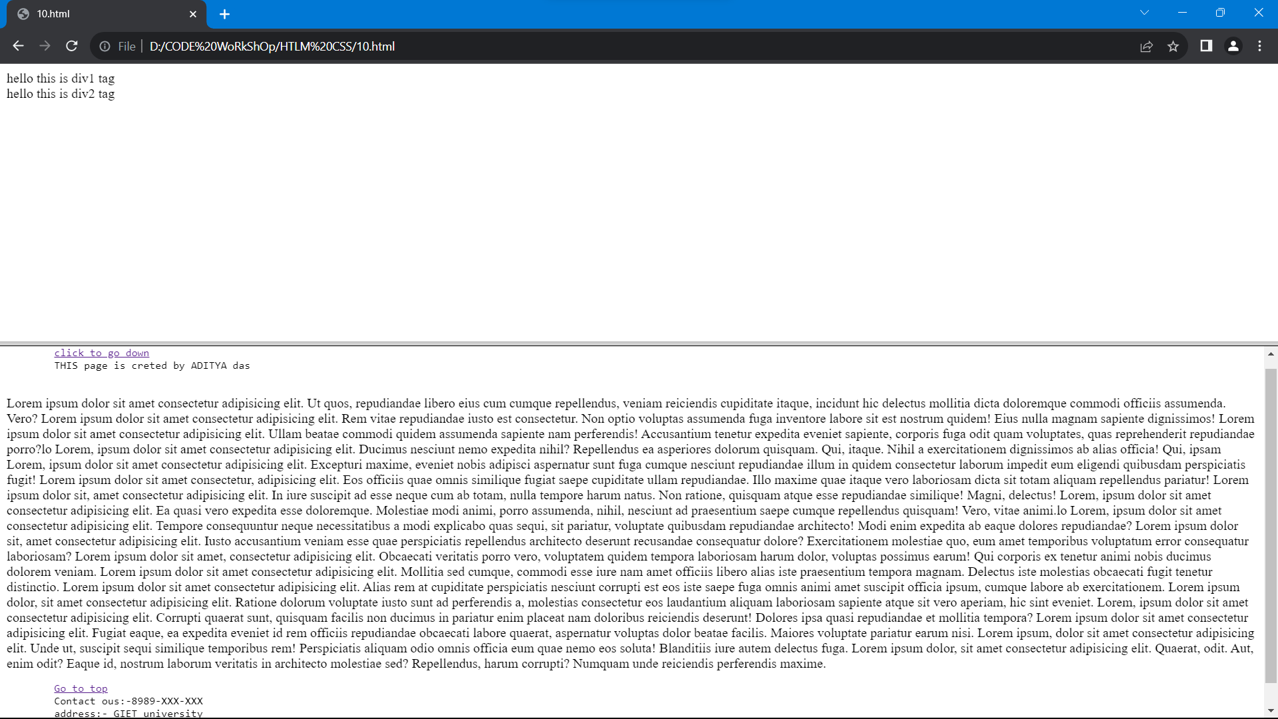

</html>

<!DOCTYPE html>

<html lang="en">

<head>

    <frameset cols="40%,20%">

        <frame src="4.html">

        <frame src="5.html">

    </frameset>

</head>

</html>

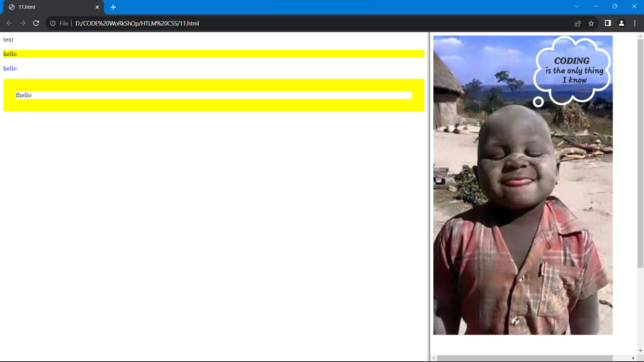

**HTML iframes:**

* HTML Iframe is used to display a nested webpage (a webpage within a webpage). The HTML <iframe> tag defines an inline frame, hence it is also called as an Inline frame.
* Generally declared in body tag**.**

**CODE:-**

<!DOCTYPE html>

<html lang="en">

<head>

    <meta charset="UTF-8">

    <meta name="viewport" content="width=device-width, initial-scale=1.0">

    <title>iframes</title>

</head>

<body>

    <iframe src="6.html" width="30%"></iframe>

    <iframe src="7.html" width="50%"></iframe>

</body>

</html>

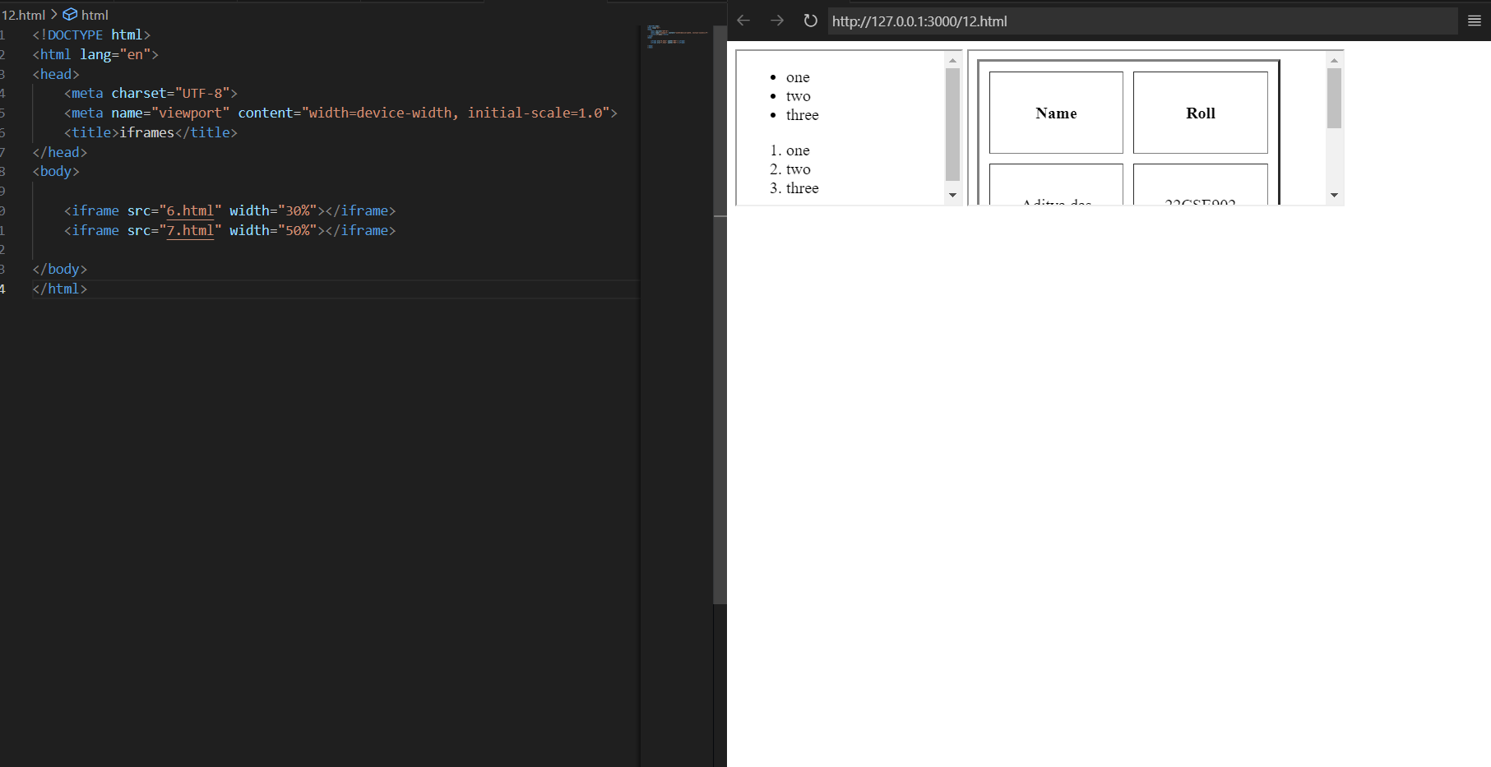

**Marquee tag:**

* The **Marquee HTML** tag is a non-standard HTML element which is used to scroll a image or text horizontally or vertically.
* In simple words, you can say that it scrolls the image or text up, down, left or right automatically.

Attributes of marquee tags are:-

* Direction= “left ” or “right” or “up” or “down”

<!DOCTYPE html>

<html lang="en">

<head>

<meta charset="UTF-8">

<meta name="viewport" content="width=device-width, initial-scale=1.0">

    <title>Document</title>

</head>

<body>

<marquee direction="up"><img src="C://Users//ADITYA DAS//Pictures//01.jpg">Donate some oney please!!!</marquee>

</body>

</html>

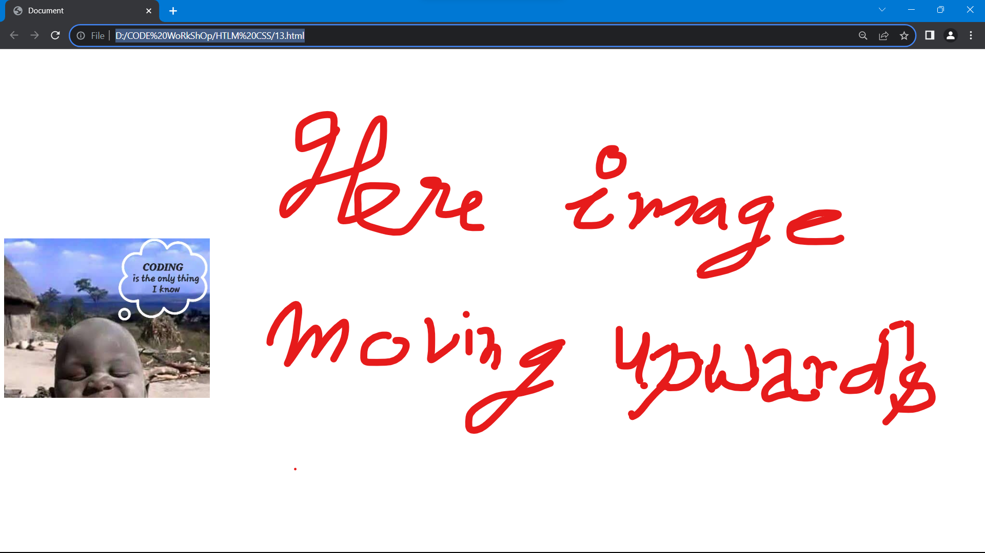

**HTML background:**

* HTML Background with Colors
* HTML Background with Images

🡪 <tagname bgcolor = "color_value">

🡪 <tagname background = "Image URL">

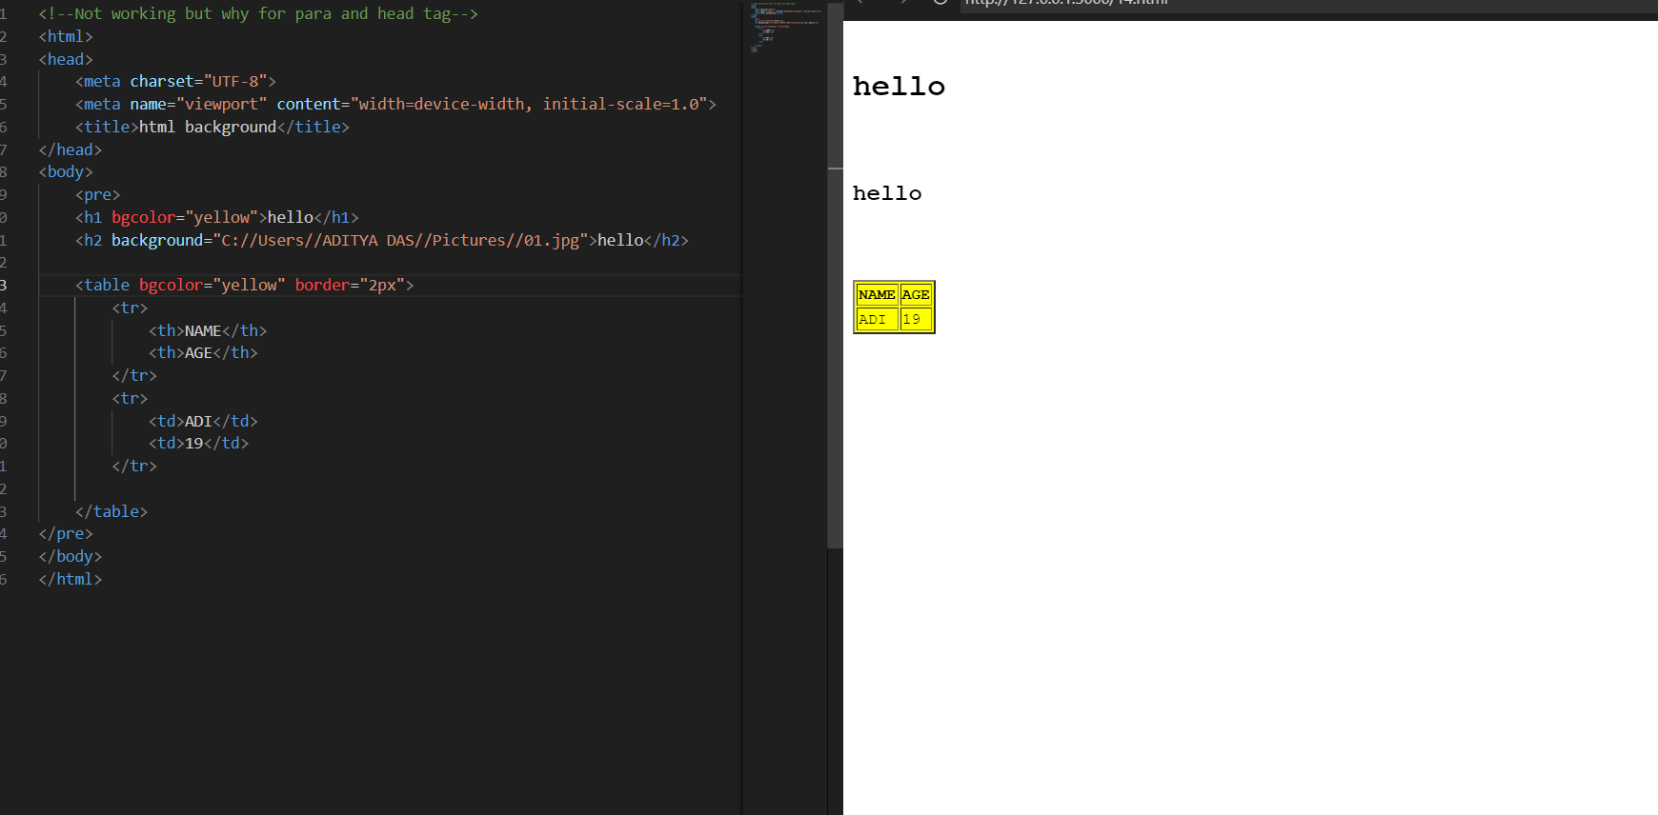

**HTML layout:**

Page layout is the part of graphic design that deals with the arrangement of visual elements on a page. Page layout is used to make the web pages look better.

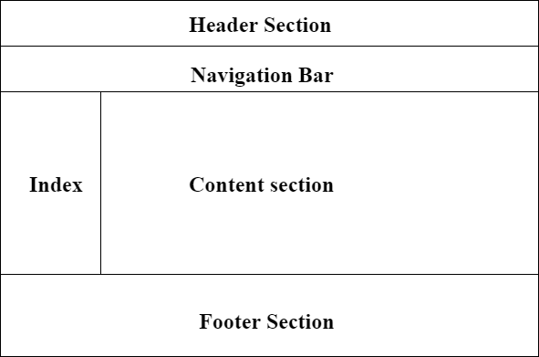

* **Header:** The part of the front end which is used at the top of the page. <header> tag is used to add a header section on web pages.s
* **Navigation bar:** The navigation bar is the same as the menu list. It is used to display the content information using hyperlinks. <nav> tag is used to add the nav section(nav elements) in web pages.
* **Index / Sidebar:** It holds additional information or advertisements and is not always necessary to be added to the page.
* **Content Section / main:** The content section is the central part where content is displayed.<main> tag is used to add the main content of the webpages.
* **Footer:** The footer section contains the contact information and other query related to web pages. The footer section is always put on the bottom of the web pages. The **<footer>** tag sets the footer on web pages.

<!DOCTYPE html>

<html lang="en">

<head>

    <meta charset="UTF-8">

    <meta name="viewport" content="width=device-width, initial-scale=1.0">

    <title>Document</title>

</head>

<body><pre>

    <header>

        ADITYA

        22CSEXXX

    </header>

    <nav style="color: chartreuse; background-color: aqua;">

        <a href="3.html">Home</a>

        <a href="4.html">about us</a>

    </nav>

    <main>

        THis an exaple of html layout.which consist of header part,footer part,section part and ad part

    </main>

    <footer>

        For more information contact to:-

        Phone number. 1238931212

        Gmail address:- test@Gmail.com

    </footer>

</pre>

</body>

</html>

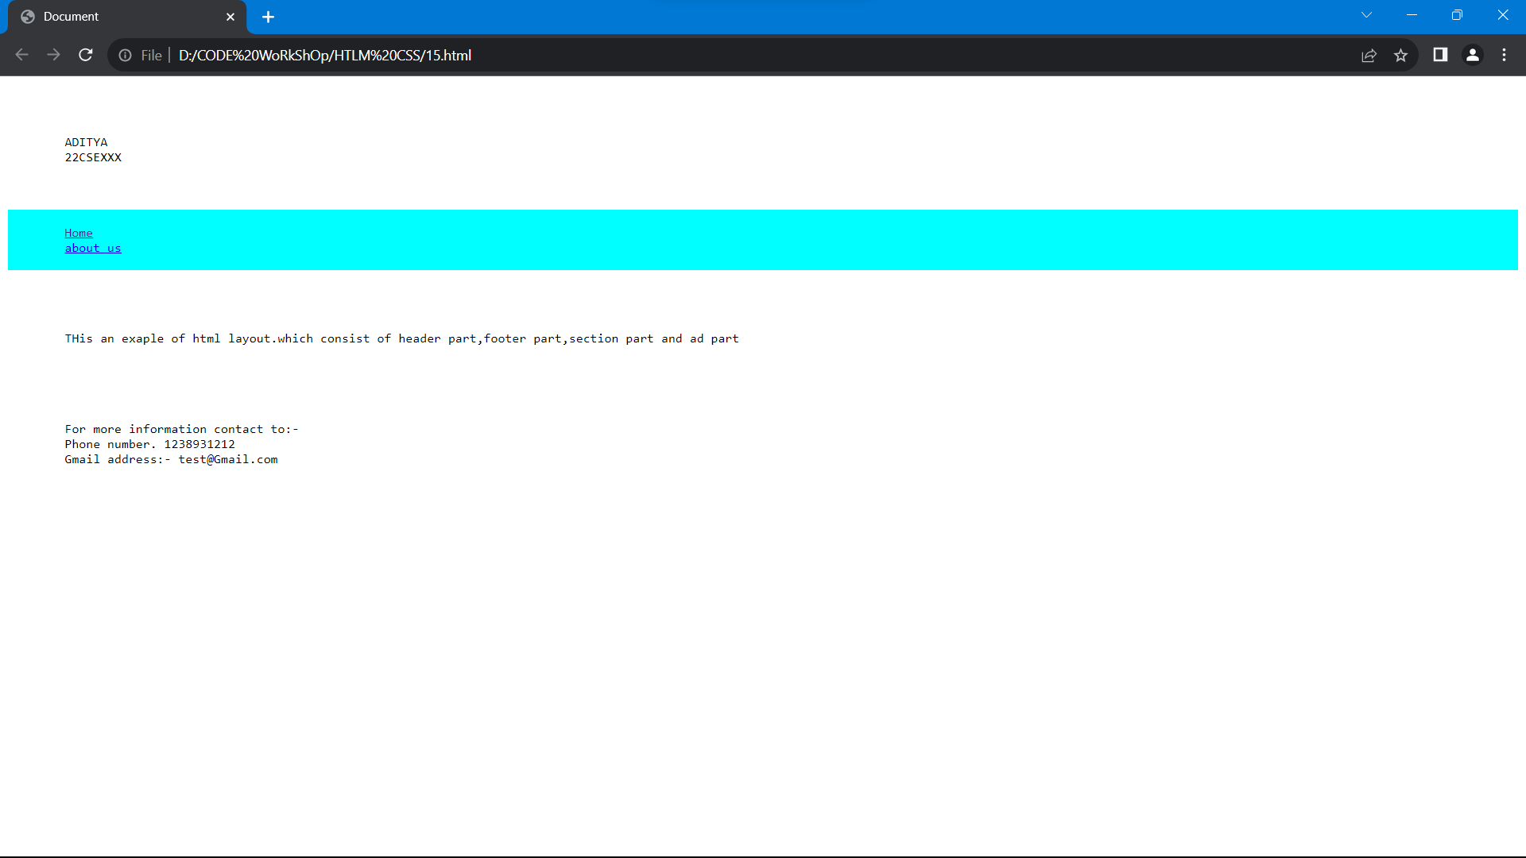

**HTML forms:**

* An HTML form is used to collect user input. The user input is most often sent to a server for processing.
* The HTML **<input>** element is the most used form element.
* An **<input>** element can be displayed in many ways, depending on the type attribute.
* Types of inputs:
  + Text
  + Radio
  + Check box
  + Submit
  + Button
  + Dropdown box
* **Checkbox:** It is used to define a checkbox field. The checkbox is shown as a square box that is ticked when it is activated. It allows the user to select one or more option among all the limited choices.
* **Radio button:** It is used to define a Radio Button. Radio Buttons are used to let the user select exactly one option from a list of predefined options. Radio Button input controls are created by using the “input” element with a type attribute having value as “radio”.
* **Text:** It is used to define a single-line text field . The default width of the text field is 20 characters.
* **Submit:** It is used to define a submit button. It is used to submit all the user value to the form handler. The Form Handler is a server page that activates a script for processing all the input values.
* **Reset:** It is used to defines a reset button. The reset button is used to reset all the form values to its initial values.

**Drop down box:**

* The <select> element is used to create a drop-down list.
* The id attribute is needed to associate the drop-down list with a label.
* The [<option>](https://www.w3schools.com/tags/tag_option.asp) tags inside the <select> element define the available options in the drop-down list.
* **date**
  + The <input type="date"> is used for input fields that should contain a date.
* **color**
  + The <input type="color"> is used for input fields that should contain a color.
* **email**
  + The <input type="email"> is used for input fields that should contain an e-mail address.
  + Depending on browser support, the e-mail address can be automatically validated when submitted.
* **image**
  + The <input type="image"> defines an image as a submit button.
  + The path to the image is specified in the src attribute.
* **password**
  + <input type="password"> defines a **password field**:
* **file**
  + The <input type="file"> defines a file-select field and a "Browse" button for file uploads.
* **quantity**
  + The <input type="number"> defines a **numeric** input field.
  + You can also set restrictions on what numbers are accepted.
* **url**
  + The <input type="url"> is used for input fields that should contain a URL address.
* **time**
  + The <input type="time"> allows the user to select a time (no time zone).
* **telephone**
  + The <input type="tel"> is used for input fields that should contain a telephone number.
* **Gsearch**
  + The <input type="search"> is used for search fields (a search field behaves like a regular text field).
* **volume**
  + The <input type=“volume"> is used to adjust volume.

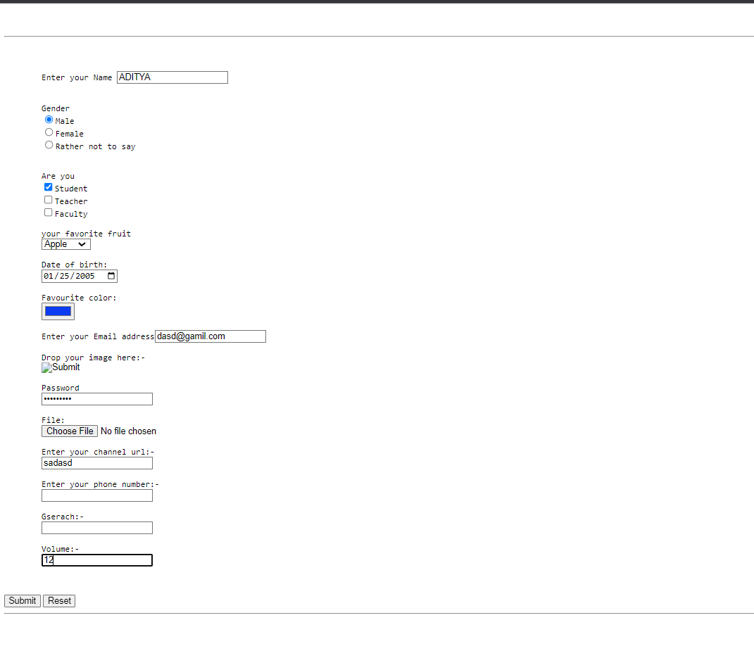

<!DOCTYPE html>

<html lang="en">

<head>

    <meta charset="UTF-8">

    <meta name="viewport" content="width=device-width, initial-scale=1.0">

    <title>HTML Form 1</title>

</head>

<body>

    <pre>

    <hr>

    <form border="2px">

        Enter your Name <input type="text">

        Gender

        <input type="radio" name="GENDER">Male

        <input type="radio" name="GENDER">Female

        <input type="radio" name="GENDER">Rather not to say

        Are you

        <input type="checkbox">Student

        <input type="checkbox">Teacher

        <input type="checkbox">Faculty

        your favorite fruit

        <select>

            <option>Apple</option>

            <option>Banana</option>

            <option>MAngo</option>

        </select>

        Date of birth:

        <input type="date">

        Favourite color:

        <input type="color">

        Enter your Email address<input type="email">

        Drop your image here:-

        <input type="image"> <!--Not working-->

        Password

        <input type="password">

        File:

        <input type="file">

        Enter your channel url:-

        <input type="url">

        Enter your phone number:-

        <input type="tel">

        Gserach:-

        <input type="search">

        Volume:-

        <input type="volume">

    </pre>

<input type="submit">

<input type="reset">

    </form>

    <hr>

</body>

</html>

